

OOP Lab 12
Templates in C++

SUBMITTED BY:
UBAID AHMAD
ROLL NO:
2410-0011
SUBMITTED TO:
Ma’am Laiba Tanveer
DATE:
23/12/2025

Task 1
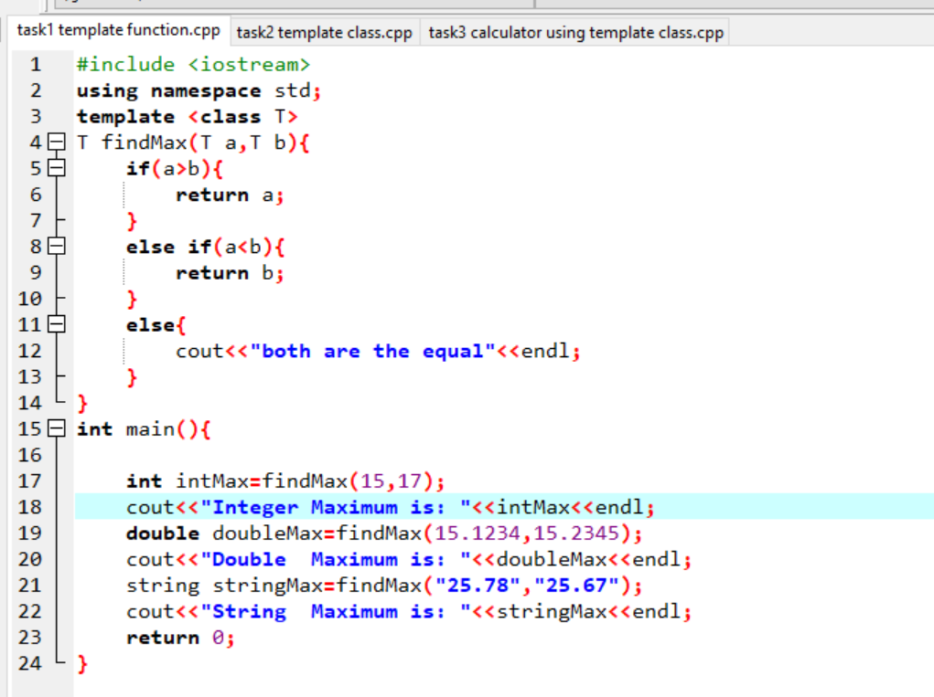
OUTPUT
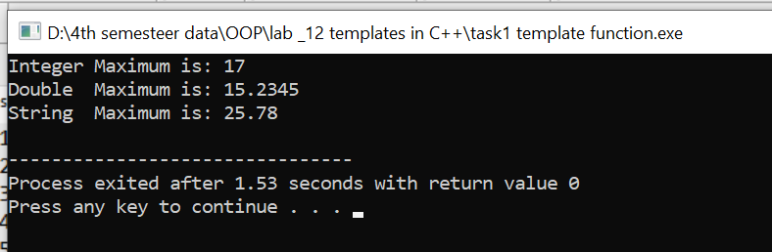

Task 2
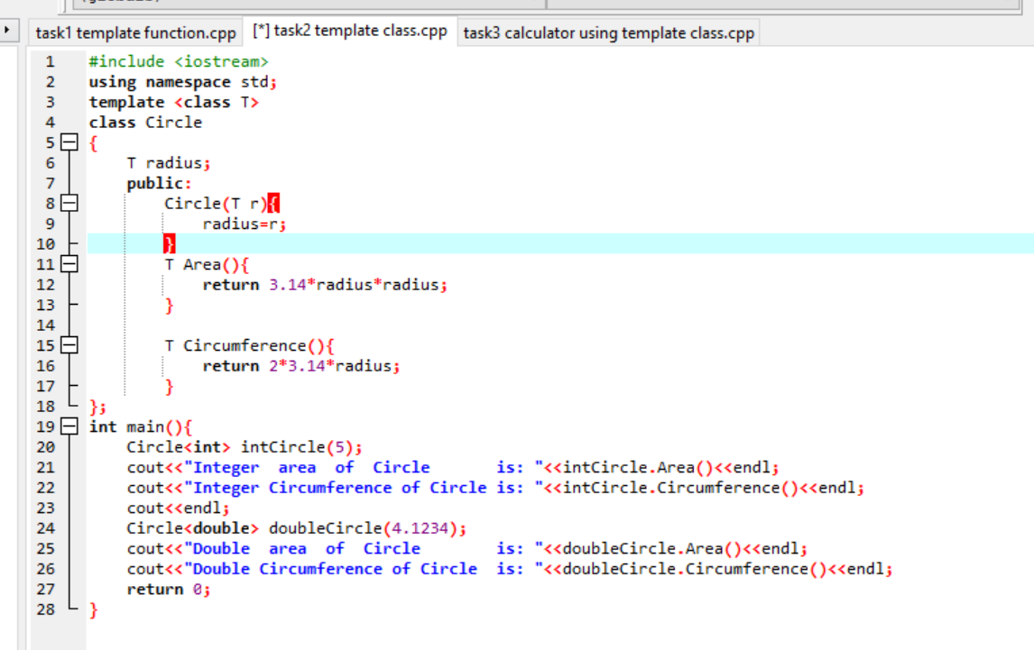
OUTPUT
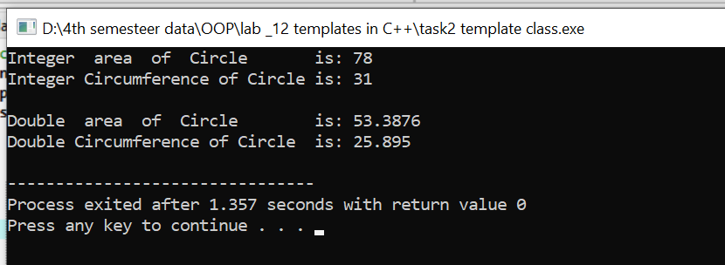

Task 3
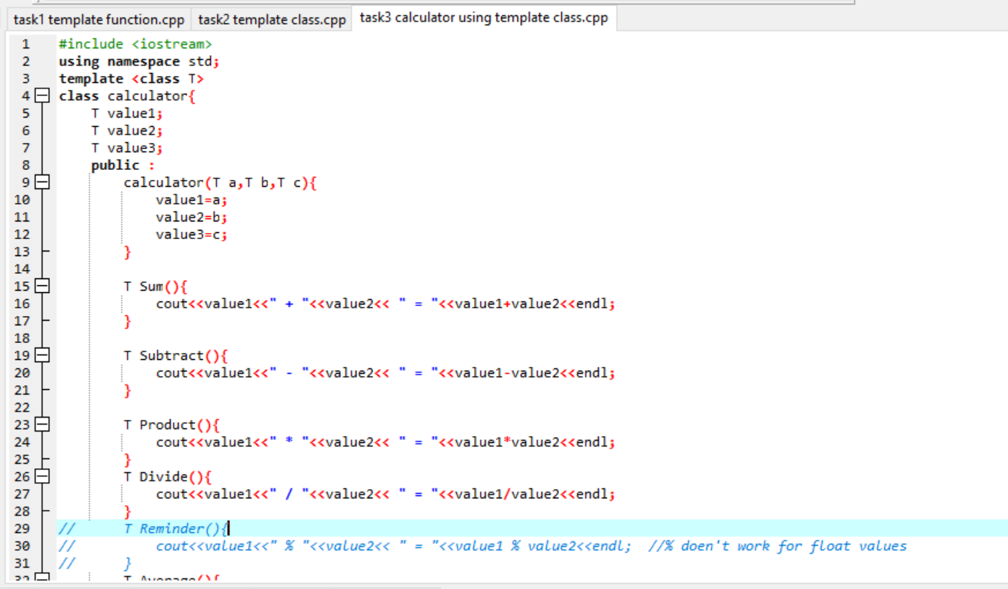
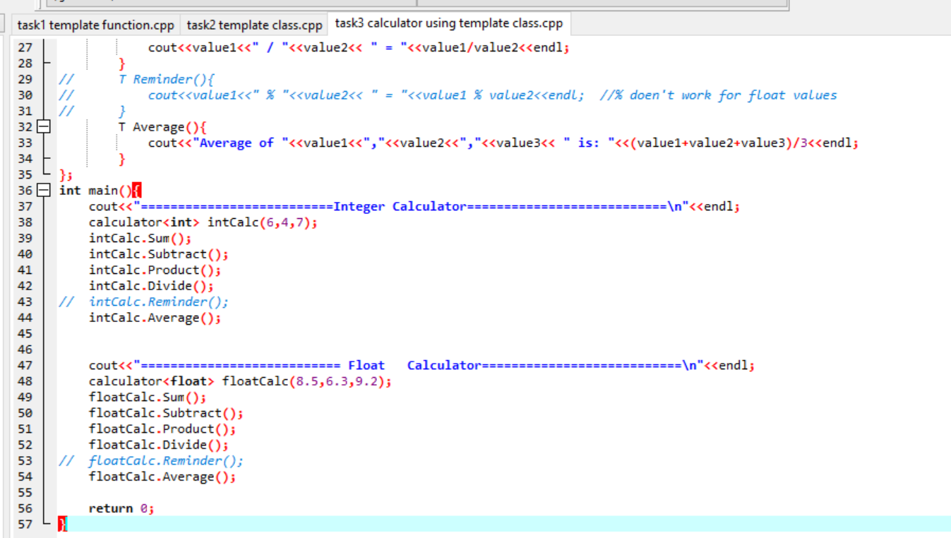
OUTPUT
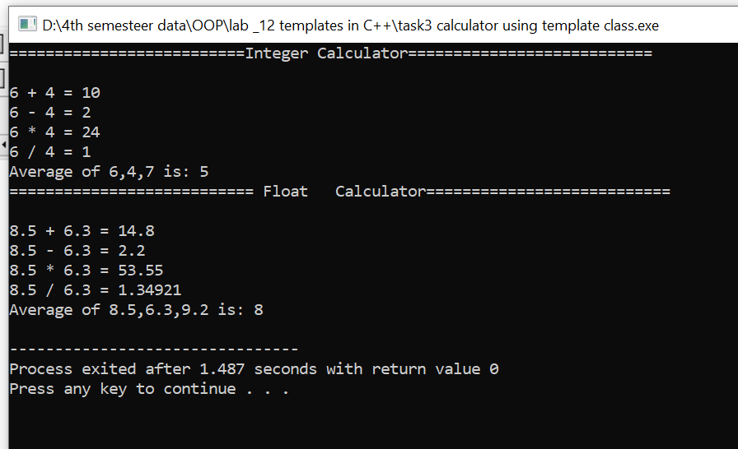

END,,,

